# Physical package

The physical package will be given to the refuges when they arrive to give them the most valuable information about Dunedin and its services to help them get settled in.

It will consist of:

* QR codes pamphlet - to google maps, the app and the site $0.10 printed
* Bus time table – $12.50 printed
* Dunedin guide - $9.30 printed
* Translation book - $10.50
* Phone book - $10 currently out of stock

Total $42.40 per package

There will be also may be more costs for designing the pamphlet, moving the physical product and unexpected tax, however people may volunteer to do some of these services for free.

As a start we will be making 100 of these physical packages which will cost around $4240 for the package and another $760 for potential extra costs. The total would be $5000

**Translation**

All of these can be translated into Arabic for the refuges that can’t read English using this website.

https://www.onlinedoctranslator.com/

Here is a translation example.

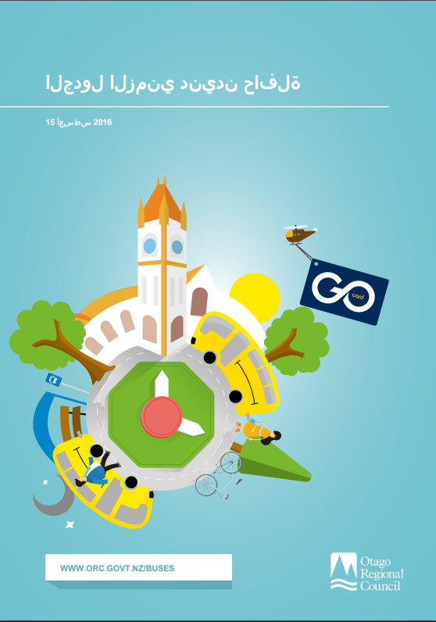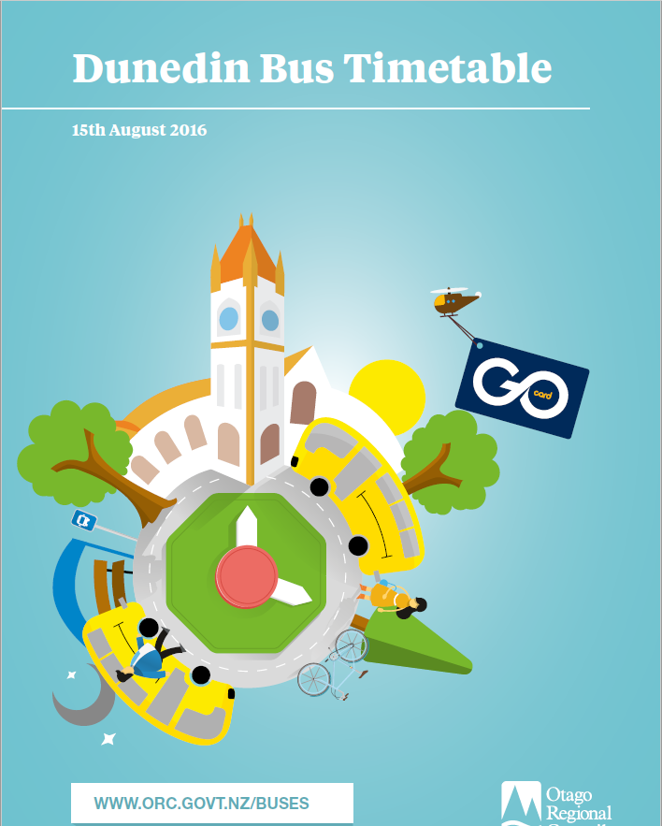

This translation isn’t 100% correct so it would pay to get a translator to read through it and correct the mistakes.

**QR codes pamphlet**

The QR codes pamphlet will have the links that lead to google maps of Dunedin the app and the website, we decided on using QR codes because the remove the language barrier.

Here is what the pamphlet might look like.

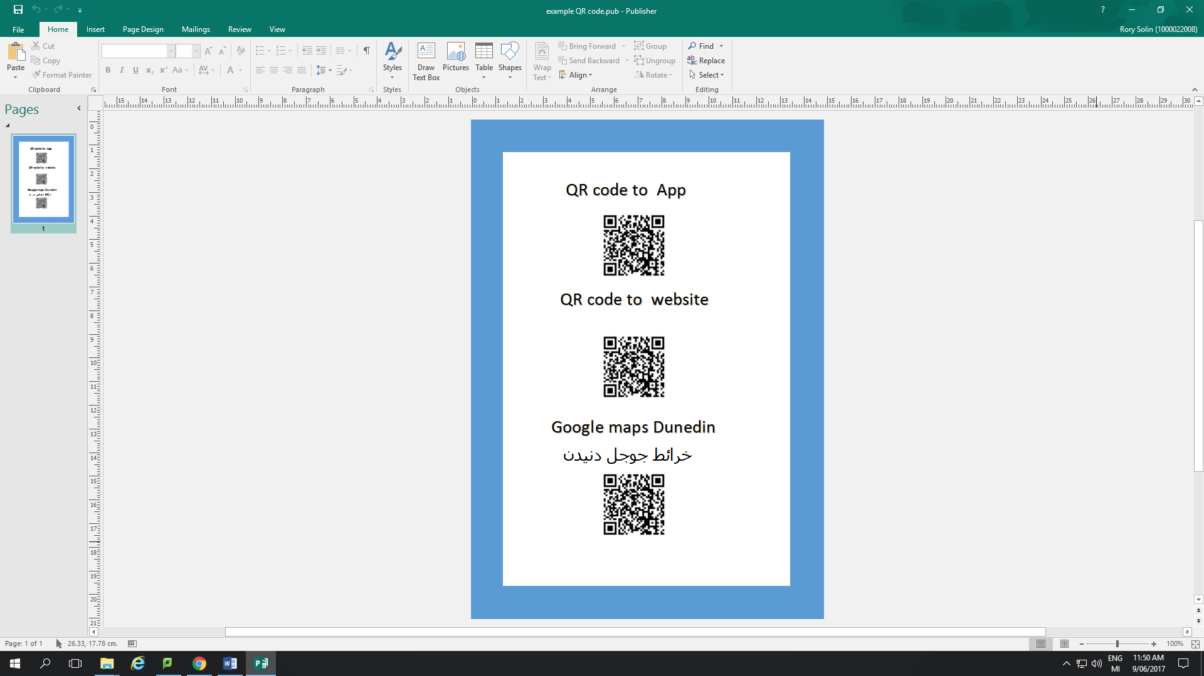

**References**

**Arabic translation book**

<https://www.bookdepository.com/M-W-Arabic-English-Dictionary-Merriam-Webster/9780877798606?ref=pd_detail_1_sims_b_p2p_1>

**Printing prices**

<http://www.printing.com/nz/choose-your-product/booklets-a4>

**Phone book**

<https://ypgbooks.co.nz/select-books/>

**Online Document Translation**

https://www.onlinedoctranslator.com/